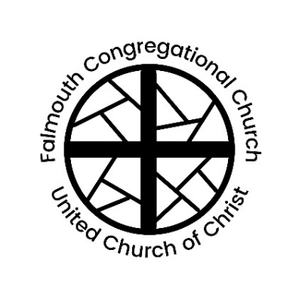
Falmouth Congregational Church
United Church of Christ
Serving Christ and Community since 1754
An Open and Affirming Congregation
The Reverend Amelia Edson
Settled Pastor & Teacher

0

267 Falmouth Rd., Falmouth, ME, 04105 | 207-781-3413 | www.falmouthcongregationalchurch.org

10:00 AM TRINITY SUNDAY June 4, 2023

THE COMMUNITY GATHERS
Welcome! If you would like more information about our community, please fill out a blue visitor card. Throughout the order of worship, if the print is in bold, words may be spoken in unison.

GATHERING MUSIC

WELCOME & ANNOUNCEMENTS

THE PASSING OF THE PEACE (Please remain in your seat while passing the peace of Christ.)
One: May the peace of Christ be with you.
All: And also with you.

ORGAN PRELUDE “Be Still and Know That I Am God”
Jennie Stephens, piano; Jan Stover, organ

CALL TO WORSHIP See screen

CALL TO CONFESSION See screen

ASSURANCE OF PARDON (From Romans 8:38-39) See Screen

CHILDREN’S MOMENT
Children are invited to join our Director of Youth and Family Programs, Hannah Daly, for Kids’ Church downstairs. Kids’ Church meets until 12, with an optional early pick-up at 11.

*HYMN “Come, Thou Almighty King” No. 27

SCRIPTURE 2 Corinthians 13:11-13 Mark Horton

SERMON Rev. Amelia Edson

BLESSING OF THE PRAYER SHAWLS
One: May God’s grace be upon this shawl
All: Warming, comforting, enfolding and embracing
One: May this mantle be a safe haven, a sacred place of security and well being
All: Sustaining and embracing in good times as well as difficult ones
One: May those who receive these shawls be cradled in hope, kept in joy, graced with peace, and wrapped in love. Amen.

*HYMN “Come, Share the Lord” No. 408

THE FEAST OF THE LORD’S SUPPER

PREFACE
One: Lift up your hearts.
All: We lift them up to God.
One: Let us give thanks to the Lord our God.
All: It is right to offer thanks and praise.

PRAYER OF THANKSGIVING

RETELLING THE STORY

THE SHARING OF THE BREAD AND CUP

*THE SUNG LORD’S PRAYER No. 307

OFFERTORY You may also donate online or on Venmo @FalmouthUCC
“The First Song of Isaiah” Jack Noble White
Pop-Up Choir; Jess Collins, solo

*DOXOLOGY No. 46
Praise God from whom all blessings flow;
Praise God all creatures here below;
Praise God above, ye heavenly host;
Creator, Christ and Holy Ghost. Amen.

*BENEDICTION

*BENEDICTION RESPONSE “Go In Peace” No. 445

ORGAN POSTLUDE “Fanfares” Edwin T. Childs

† Musical material is presented under CCLI License #11176026
* Please stand in body or spirit

Thank you to our worship participants:
Presiding: Rev. Amelia Edson
Minister of Music: Jan Stover
Ushers: Lydia Hill, Kim Mason, Karin Kurry, Mark Horton
Online Worship: Virginia Eddy, Tom Stegemann, Jack Gervais

We are pleased to let you know that Falmouth Congregational Church may now receive your offerings via Venmo by using the name “@FalmouthUCC” or by searching “Falmouth Congregational Church UCC” in Venmo, under the “Charities” section.

Please join us for refreshments in Fellowship Hall
following the service.

🙚🙚 ❖ 🙙🙙

Next Sunday’s Lectionary
Genesis 12:1-9; Psalm 33:1-12 (or Hosea 5:15-6:6 and Psalm 50:7-15);
Romans 4:13-25; Matthew 9:9-13, 18-26

Inspired by a Trinity Sunday prayer found on the Rev-o-lution blog.
Adapted from a prayer written by the Rev. Katherine Lee Baker and posted on the Reformed Church in America website. https://www.rca.org/
Blessing for a Completed Prayer Shawl, Knitting into the Mystery: A Guide to the Shawl-Knitting Ministry by Susan S. Jorgensen

