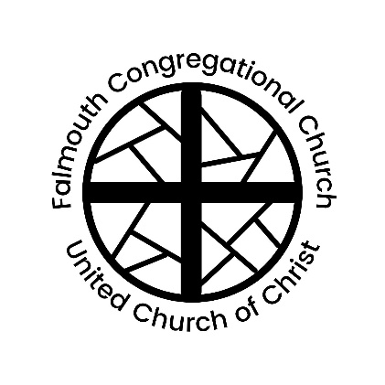
Falmouth Congregational Church
United Church of Christ

Serving Christ and Community since 1754
An Open and Affirming Congregation
The Reverend Amelia Edson
Settled Pastor & Teacher

267 Falmouth Rd., Falmouth, ME, 04105 | 207-781-3413 | www.falmouthcongregationalchurch.org

10:00 AM FOURTH SUNDAY AFTER EPIPHANY January 29, 2023

THE COMMUNITY GATHERS
Welcome! If you would like more information about our community, please fill out a blue visitor card. Throughout the order of worship, if the print is in bold, words may be spoken in unison.

GATHERING MUSIC

WELCOME & ANNOUNCEMENTS

THE PASSING OF THE PEACE (Please remain in your seat while passing the peace of Christ.)
One: May the peace of Christ be with you.
All: And also with you.

ORGAN PRELUDE “Grace Greater Than Our Sins” arr. James Pethel

CALL TO WORSHIP
One: God of grace, You have given us minds to know You
All: hearts to love You, and voices to sing Your praise.
One: Fill us with Your Spirit
All: that we may celebrate Your glory
One: and worship You in spirit and in truth;
All: through Jesus Christ our Lord. Amen.

CALL TO CONFESSION & ASSURANCE OF PARDON
One: Lord God, who by the leading of a star made manifest Your Son to the world.
All: We pray that You might mercifully correct our wanderings.
One: And by the guiding radiance of Your compassion bring us to Your truth.
~

One: The compassion of the Lord is from everlasting to everlasting.
All: God’s mercy is new every morning.
One: Let us believe the good news of the gospel.
All: In Jesus Christ we are forgiven. Amen.

CHILDREN’S MOMENT
Children are invited to join our Director of Youth and Family Programs, Hannah Daly, for Kids’ Church downstairs. Kids’ Church meets until 12, with an optional early pick-up at 11.

*HYMN “Come, Thou Font of Every Blessing” No. 16

SCRIPTURE Matthew 5:1-12 Cathy Bowden

LAY SERMON Tom Crosby

BLESSING OF GUIDING STAR WORDS

*HYMN “Amazing Grace!” No. 546

PRAYERS OF THE PEOPLE

THE LORD’S PRAYER

OFFERTORY “Sing Them Over Again to Me” arr. Gilbert Martin
Chancel Choir
Kristen Tripp, solo

*DOXOLOGY No. 46
Praise God from whom all blessings flow;
Praise Him, all creatures here below;
Praise Him above, ye heavenly host;
Creator, Christ and Holy Ghost. Amen.

BENEDICTION

*BENEDICTION RESPONSE “Go Light Your World” Chris Rice
Carry your candle, run to the darkness
Seek out the hopeless, confused and torn
Hold out your candle for all to see it
Take your candle, and go light your world
Take your candle, and go light your world.

ORGAN POSTLUDE “Toccata on ‘Amazing Grace’” J. Christopher Pardini

† Musical material is presented under CCLI License #11176026
* Please stand in body or spirit

🙚🙚 ❖ 🙙🙙

Next Sunday’s Lectionary
Isaiah 58:1-9a (9b-12); Psalms 112:1-9 (10); 1 Corinthians 2:1-12 (13-16); Matthew 5:13-20

Thank you to our worship participants:
Presiding: Rev. Amelia Edson
Lay Preacher: Tom Crosby
Minister of Music: Jan Stover
Ushers: Judy Crosby, Tom Crosby
Liturgist: Cathy Bowden
Online Worship: Virginia Eddy, Tom Stegemann, Jack Gervais

Please join us for refreshments provided by the Christian Education Committee following the service.

Book of Common Worship, Louisville: Westminster/John Knox Press, 1993

